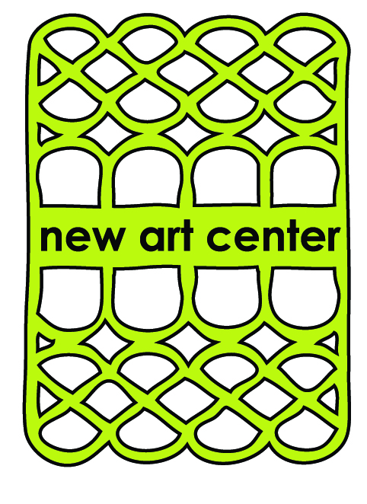

Dynamic Color & Expressive Painting
Instructor: Martha Wakefield

Paint: Here is a suggested list if you have not currently invested in any paints. If you already own yellows, reds and blues and greens please bring what you have. You will need Titanium White and a Black preferable Carbon or Ivory Black.

Make sure you are buying professional paint not student grade. Golden Paints, M Graham, Holbein, Liquitex, Blick etc. Also please read the label if the word Hue follows the name it means another color or filler has been added. Pigment is the most expensive component.

- Titanium white (or zinc/titanium mixture)
- cadmium yellow light or Hansa yellow light
- cadmium orange or vat orange
- napthol red or cadmium red medium
- alizarin crimson
- cadmium green or permanent green light
- phthalo green
- ultramarine blue
- dioxazine purple
- Carbon or Ivory Black

Paint Surface for warm up exercises and painting: Here are a few suggestions for our warm up exercises about 10 - 20 sheets.

Paper for acrylic/watercolors – at least 140 lb or more either cold press or hot press. @ 11” x 14” for exercises. This may need a layer of gesso. Watercolor blocks are an option, OR canvas paper: http://www.dickblick.com/items/09811-1006/ the same size 11 x 14

Tape: ½ inch white artist tape or masking tape for dividing the paper. For attaching paper to a support you will need 1” https://www.dickblick.com/products/artist-tape/. Please do not bring any colored tape ie blue or green.

Brushes: Your choice. I recommend a mix of brushes shapes and sizes: filberts, flats, rounds. Have at least three brushes on hand small, medium and large being 1.5 inches.

Palette knife: Any palette knife will do. As a suggestion if this is a new tool: http://www.dickblick.com/products/loew-cornell-fine-quality-steel-palette-knives/

Container for water if working in watermedia
Spritzer bottle if working in watermedia
Medium in a closed container if working in oils only Gamsol Solvent Fee Oil Medium or Weber Liquiglaze Natural Oil Medium
A roll of paper towels or cotton rags.

Support surface: A board or foamcore or any strong surface larger than the paper that can support that sheet of paper taped to it and not bend, fold or buckle.

Palette: You can buy palette paper pads @ http://www.dickblick.com/items/24124-1034/

Or a roll of freezer paper works just as well (I have only found it available now at Wegman’s. Stop&Shop used to carry it. ). If you buy a palette pad get a large size so you have room to play w/ mixing colors. I like to tape my freezer paper to a sturdy board and not the table.

Gloves: nitrile, latex or vinyl, essential for keeping your hands clean while you mess about on the surface of your painting. You can get them at drug stores or hardware stores

Apron or clothes that like paint

Graphite pencil : Any pencil will do (Just an FYI I really like these woodless one: https://www.dickblick.com/products/koh-i-noor-progresso-woodless-graphite-pencils/).

Scrapers: old credit cards, hardware store paint/grout tools plastic or metal. I will have a few on hand to use.

Sharpie marker

Notebook and pen/pencil for notes

Sketchbook: at least 11’ x 14”or bigger

Landscape photos. Please bring a few landscape photos printed out on 8.5 x 11 copy paper. Consider that these landscape photos have a personal connection to you and inspire you to capture that connection using paint. Bring a black & white version same size also of one of your favorite photos. Please do not plan to work on images directly from your cell phone.

Note: even though I use DickBlick.com as the main supplier listed here there is no monetary gain or affiliation with them on my part. I also use cheapjoes and jerrysartarama for supplies. These links are for reference only. Other online art resources:

www.cheapjoes.com
www.jerrysartarama.com
www.artistcraftsman.com

Any questions please call 617-513-3515 or email me @ marthawakefield514@gmail.com

